CSE6344
Assignment 1 Report

Group ID: <place your group ID here>
<name> | <student #>
<name> | <student #>
<name> | <student #>
<name> | <student #>

Date: | <place the date of submission here>
Contents
Contents 2
1 Introduction 3
1.1 Set of Strings 3
1.2 Group Distribution 3
1.3 Programs 3
2 Set 1 4
2.1 Strings 4
2.2 Regular Expression 4
2.3 NFA 4
2.4 DFA 4
2.5 Test Data 4
2.6 Test Results 4
3 Set 2 5
3.1 Strings 5
3.2 Regular Expression 5
3.3 NFA 5
3.4 DFA 5
3.5 Test Data 5
3.6 Test Results 5
4 Set 3 6
4.1 Strings 6
4.2 Regular Expression 6
4.3 NFA 6
4.4 DFA 6
4.5 Test Data 6
4.6 Test Results 6
5 Combined DFA 7
5.1 Integration 7
5.2 Regular Expression 7
5.3 DFA 7
5.4 Test Data 7
5.5 Test Results 7
6 Conclusion 8
7 Supporting Materials 9

Introduction

Set of Strings
<Place the list of strings here.>

Group Distribution
<Describe how the strings are distributed to group members.>

Set No. | Group Member | Strings
1. | Member Name | String 1  String 2  …
2.
3.
4.

Programs
<write a brief description about the programs>

Set 1

Strings
{*n*, *x*, *g*, *2*, nx*}

Regular Expression
[*(n ∪ x ∪ g ∪ 2) ∪ nx ]*

NFA
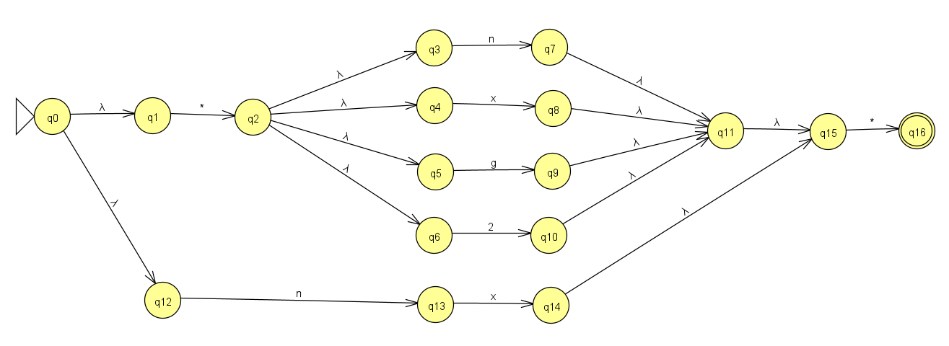

DFA
ε-close(q0) = {q0, q1, q12}
ε-close(q1) = {q1}
ε-close(q2) = {q2, q3, q4, q5, q6}
ε-close(q3) = {q3}
ε-close(q4) = {q4}
ε-close(q5) = {q5}
ε-close(q6) = {q6}
ε-close(q7) = {q7, q11, q15}
ε-close(q8) = {q8, q11, q15}
ε-close(q9) = {q9, q11, q15}
ε-close(q10) = {q10, q11, q15}
ε-close(q11) = {q11, q15}
ε-close(q12) = {q12}
ε-close(q13) = {q13}
ε-close(q14) = {q14, q15}
ε-close(q15) = {q15}
ε-close(q16) = {q16}

δ | * | n | x
{q0} | ε-close(δ(ε-close(q0), *)) = {q2, q3, q4, q5, q6} | ε-close(δ(ε-close(q0), n)) = {q13} | ∅
{q2} | ∅ | ε-close(δ(ε-close(q2), n)) = {q7, q11, q15} | ε-close(δ(ε-close(q2), x)) = {q8, q11, q15}
{q3} | ∅ | ε-close(δ(ε-close(q3), n)) = {q7, q11, q15} | ∅
{q4} | ∅ | ∅ | ε-close(δ(ε-close(q4), x)) = {q8, q11, q15}
{q5} | ∅ | ∅ | ∅
{q6} | ∅ | ∅ | ∅
{q7} | ε-close(δ(ε-close(q7), *)) = {q16} | ∅ | ∅
{q8} | ε-close(δ(ε-close(q8), *)) = {q16} | ∅ | ∅
{q9} | ε-close(δ(ε-close(q9), *)) = {q16} | ∅ | ∅
{q10} | ε-close(δ(ε-close(q10), *)) = {q16} | ∅ | ∅
{q11} | ε-close(δ(ε-close(q11), *)) = {q16} | ∅ | ∅
{q13} | ∅ | ∅ | ε-close(δ(ε-close(q13), x)) = {q14, q15}
{q14} | ε-close(δ(ε-close(q14), *)) = {q16} | ∅ | ∅
{q15} | ε-close(δ(ε-close(q15), *)) = {q16} | ∅ | ∅
{q16} | ∅ | ∅ | ∅

δ | g | 2
{q0} | ∅ | ∅
{q2} | ε-close(δ(ε-close(q2), g)) = {q9, q11, q15} | ε-close(δ(ε-close(q2), 2)) = {q10, q11, q15}
{q3} | ∅ | ∅
{q4} | ∅ | ∅
{q5} | ε-close(δ(ε-close(q5), g)) = {q9, q11, q15} | ∅
{q6} | ∅ | ε-close(δ(ε-close(q6), 2)) = {q10, q11, q15}
{q7} | ∅ | ∅
{q8} | ∅ | ∅
{q9} | ∅ | ∅
{q10} | ∅ | ∅
{q11} | ∅ | ∅
{q13} | ∅ | ∅
{q14} | ∅ | ∅
{q15} | ∅ | ∅
{q16} | ∅ | ∅

DFA table
δ | * | n | x | g | 2
{q0} | {q2, q3, q4, q5, q6} | {q13} | ∅ | ∅ | ∅
{q2, q3, q4, q5, q6} | ∅ | {q7, q11, q15} | {q8, q11, q15} | {q9, q11, q15} | {q10, q11, q15}
{q13} | ∅ | ∅ | {q14, q15} | ∅ | ∅
{q7, q11, q15} | {q16} | ∅ | ∅ | ∅ | ∅
{q8, q11, q15} | {q16} | ∅ | ∅ | ∅ | ∅
{q9, q11, q15} | {q16} | ∅ | ∅ | ∅ | ∅
{q10, q11, q15} | {q16} | ∅ | ∅ | ∅ | ∅
{q14, q15} | {q16} | ∅ | ∅ | ∅ | ∅
{q16} | ∅ | ∅ | ∅ | ∅ | ∅
∅ | ∅ | ∅ | ∅ | ∅ | ∅

δ | * | n | x | g | 2
A | B | C | J | J | J
B | J | D | E | F | G
C | J | J | H | J | J
D | I | J | J | J | J
E | I | J | J | J | J
F | I | J | J | J | J
G | I | J | J | J | J
H | I | J | J | J | J
I | J | J | J | J | J
J | J | J | J | J | J

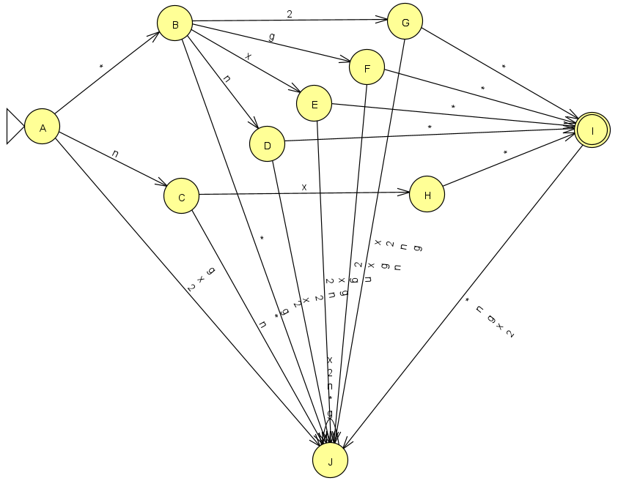
Test Data
<Place the accept and reject strings to be used to test the DFA here.>

Accept Strings | Reject Strings

Test Results
<Place the screenshot(s) of the JFLAP test results here.>

Set 2

Strings
<Place the list of strings here.>

Regular Expression
<Write the regular expression for the strings here.>

NFA
<Draw the NFA for the regular expression and place here.>

DFA
<Show the NFA to DFA conversion steps here, and place the diagram from JFLAP here.>

Test Data
<Place the accept and reject strings to be used to test the DFA here.>

Accept Strings | Reject Strings

Test Results
<Place the screenshot(s) of the JFLAP test results here.>

Set 3

Strings
<Place the list of strings here.>

Regular Expression
<Write the regular expression for the strings here.>

NFA
<Draw the NFA for the regular expression and place here.>

DFA
<Show the NFA to DFA conversion steps here, and place the diagram from JFLAP here.>

Test Data
<Place the accept and reject strings to be used to test the DFA here.>

Accept Strings | Reject Strings

Test Results
<Place the screenshot(s) of the JFLAP test results here.>

Set 4

Strings
<Place the list of strings here.>

Regular Expression
<Write the regular expression for the strings here.>

NFA
<Draw the NFA for the regular expression and place here.>

DFA
<Show the NFA to DFA conversion steps here, and place the diagram from JFLAP here.>

Test Data
<Place the accept and reject strings to be used to test the DFA here.>

Accept Strings | Reject Strings

Test Results
<Place the screenshot(s) of the JFLAP test results here.>

Combined DFA

Integration
<Describe how the DFAs from the different sets are integrated. (explain the steps) >

Regular Expression
<Write the combined regular expression for the strings here.>

DFA
<Place the DFA diagram from JFLAP here.>

Test Data
<Place the accept and reject strings to be used to test the DFA here.>

Accept Strings | Reject Strings

Test Results
<Place the screenshot(s) of the JFLAP test results here.>

Conclusion

<Write a brief description about overall assignment findings, activities and any relevant comments or opinions>

Supporting Materials
<This section is Optional. Place any additional items that may describe and support your assignment work.>

